Chapter 2 p.17

Ransomware breaches per month per 100,000 organizations

We observed an overall increase in successful ransomware attacks with a sharp decrease in March-April.

Line graph showing Ransomware breaches per month per 100,000 organizations. X-axis represents the period from Jul 2022 to Jun 2023 and y-axis represents numbers from 0 to 40 in intervals of 5. Ransomware attacks increase gradually from approx. 13 in July 22, show a sharp decrease in March and April 23, and goes to approx. 10 in June 23.

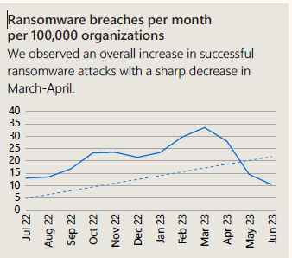

Telemetry sources: Microsoft Security Graph, Microsoft Defender for Endpoint, Microsoft Defender for Cloud Apps, Microsoft Defender for Identity, Microsoft Defender for Office 365, Azure AD Identity Protection, Microsoft Defender Threat Intelligence